WRITE A PROGRAM TO ILLUSTRATE TABLE TAG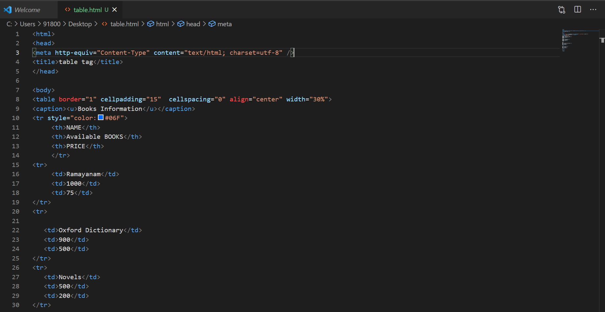

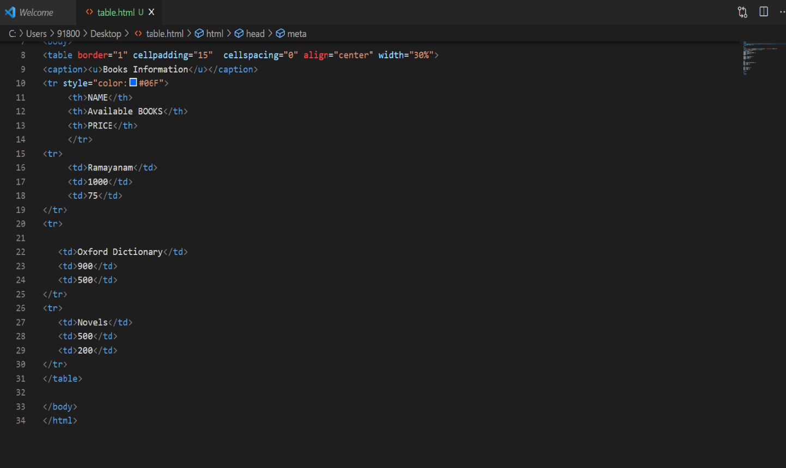

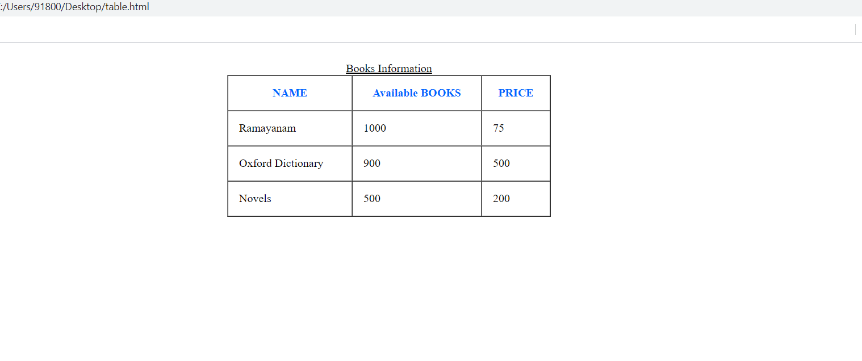

WRITE A PROGRAM TO ILLUSTRATE FRAME TAG
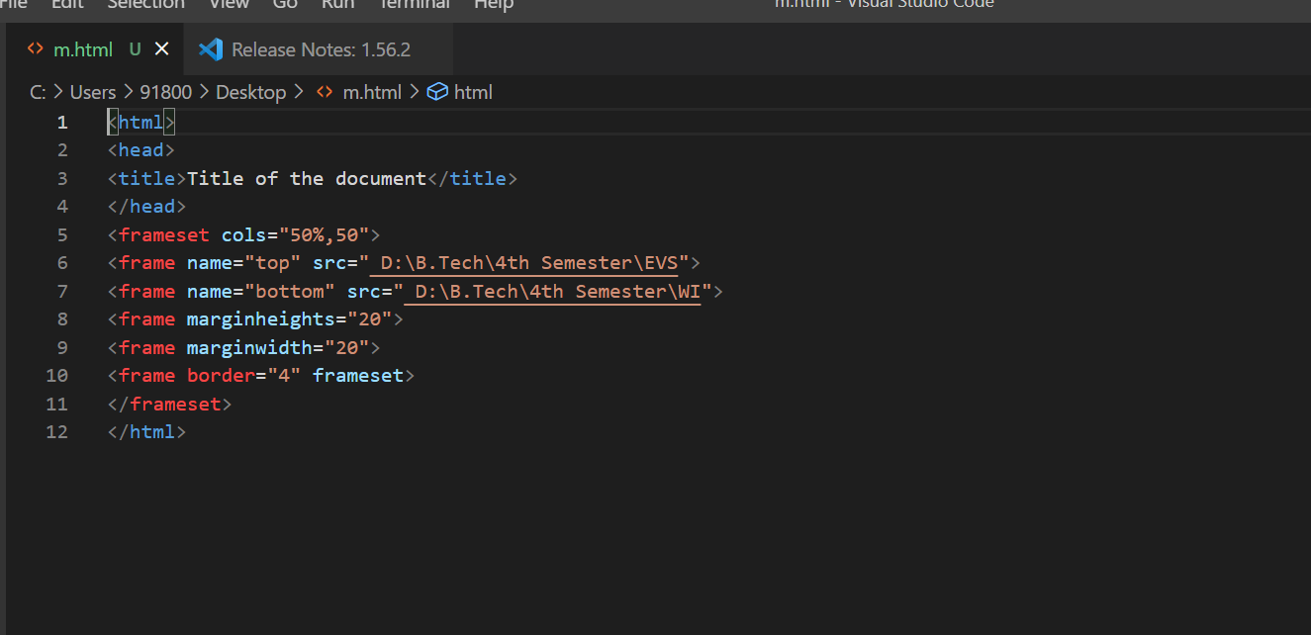
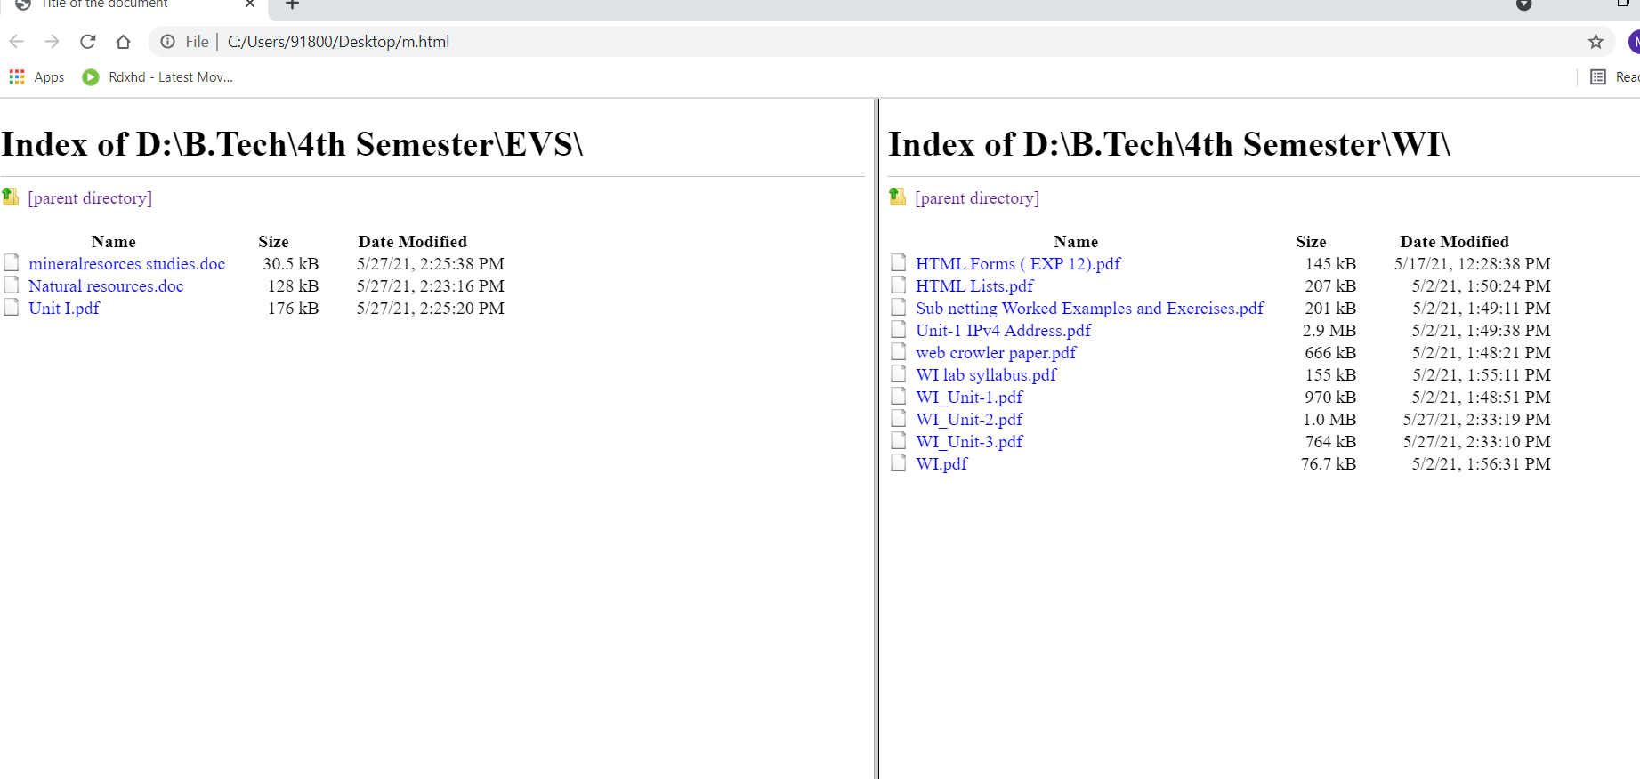
WRITE A PROGRAM TO ILLUSTRATE FORM TAG
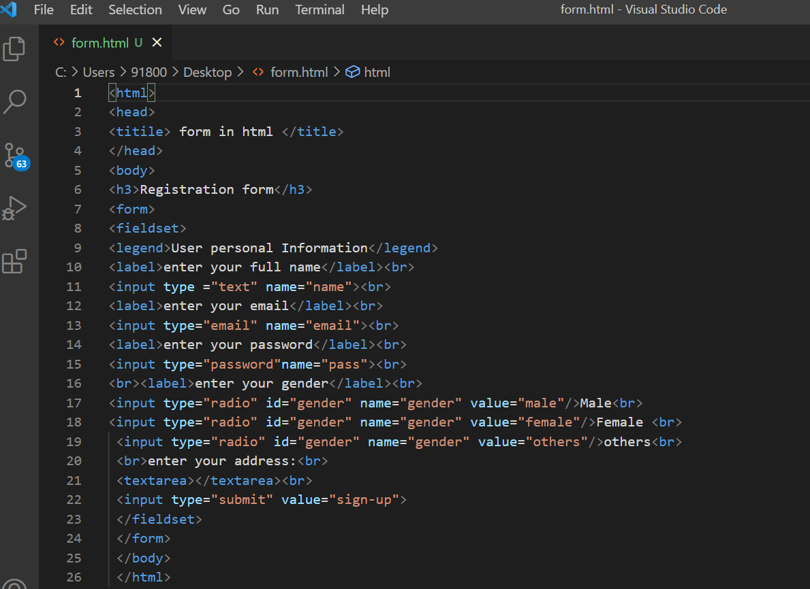
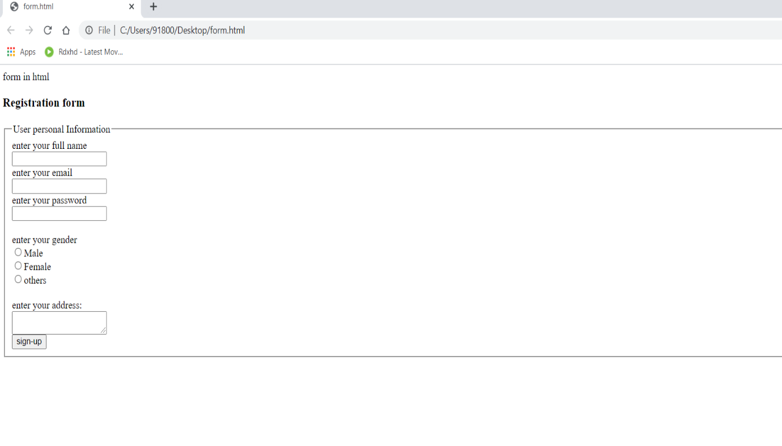
WRITE A PROGRAM TO CREATE A SIMPLE FORM TO SUBMIT USER INPUT LIKE HIS NAME,AGE,ADDRESS AND FAVORITE SUBJECT,MOVIE,SINGER.
